Newsletter 13 of MEDIATS project
May 2022 - December 2022

In this issue you will find news and updates of all partners:
- News from KROK University
- News from partners
- International Highlight Event 2
- Project Steering Committee 6
- The mediats project – strong cross-university initiative
- Mediation Training by Rector of the Netherlands Business Academy

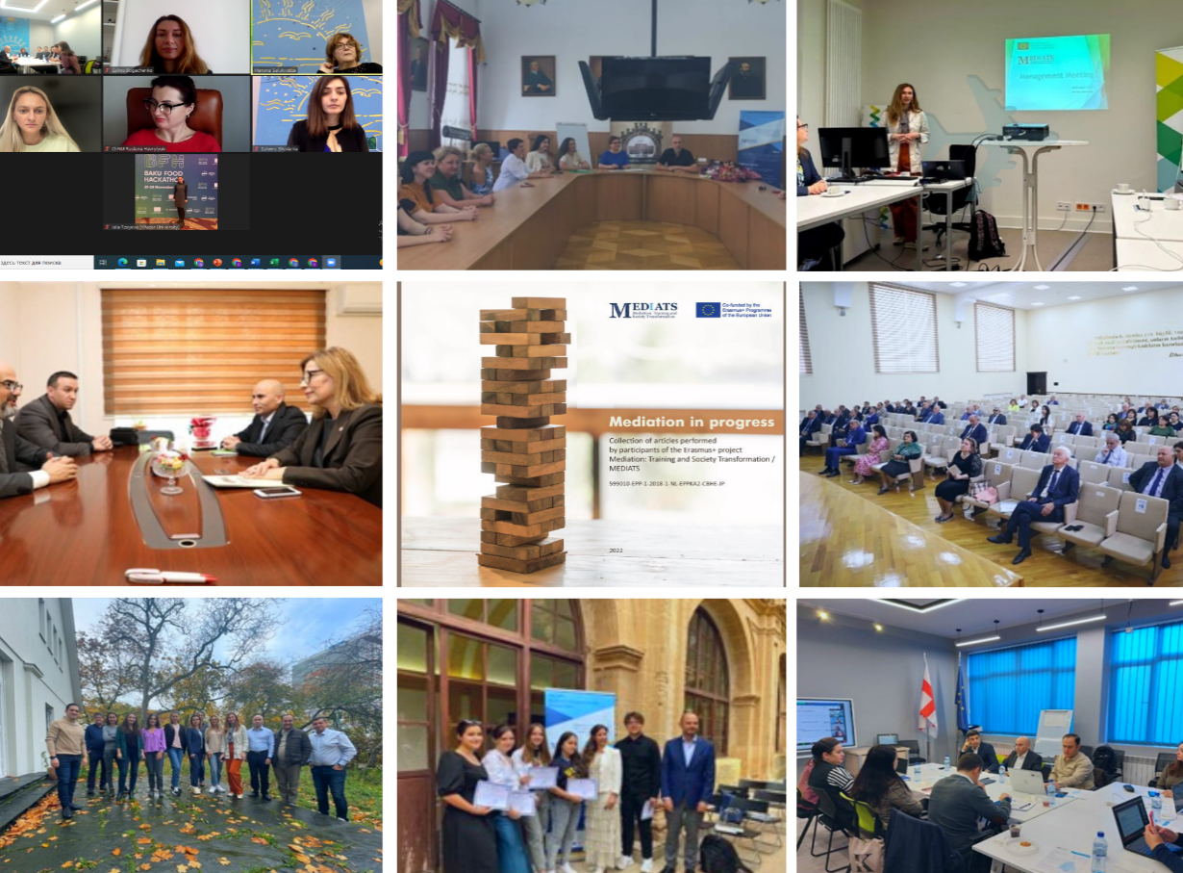

“The European Commission’s support for the production of this publication does not constitute an endorsement of the contents, which reflect the views only of the authors, and the Commission cannot be held responsible for any use which may be made of the information contained therein”.

News from KROK

Mediation Training by Rector of the Netherlands Business Academy

On August 8-12, 2022, Jan van Zwieten, Rector of the Netherlands Business Academy, together with Jan Thomas van Zwieten, Manager of NLBA, visited «KROK» University.
In order to disseminate the values of mediation into Ukrainian society, prof. van Zwieten conducted an open practical training for interested persons, where participants received theoretical information about mediation, learned about the experience of the Netherlands and were able to practice the skills of mediator.
During the visit, experts from Netherlands had meetings with the teams of Educational and Scientific Institute of International Education, KROK Business School and discussed implementation of Master degree program «Mediation and Conflict Management», maintenance of the mediators' register and students’ certification. Jan van Zwieten reviewed training materials of the program and provided useful recommendations. The participants discussed the sustainability of the project and further initiatives in the field of mediation.

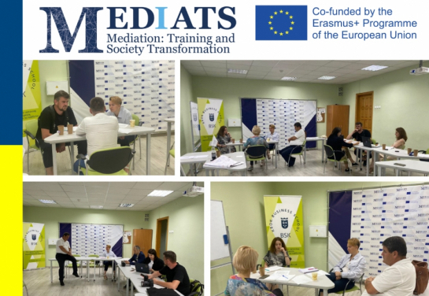

Sustainability Training of Mediation Project

On July 26, 2022, as part of MEDIATS project «Mediation: Training and Society Transformation / MEDIATS», an online training was held to ensure the sustainability of the project.
The organizer of the training was Oliver Schmidt, MEDIATS project quality manager, Director of German consulting company Hultgren Nachhaltigkeitsberatung UG.
During the training, the participants discussed in detail the state of project implementation at the moment, project results, strategies for ensuring sustainability after the end of the funding period. While working in groups, the partners reflected and presented what else can be done to obtain a long-term impact. As a result of the training, the strategy for ensuring the sustainability of the results of the MEDIATS project was updated.

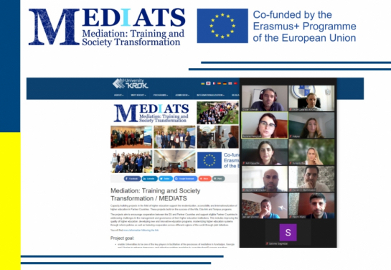

Sustainability Events of Erasmus+ Project MEDIATS
On October 21-22, 2022, sustainability events of Erasmus+ project «Mediation: Training and Society Transformation» were organized in Berlin, Germany, with participation of MEDIATS partners from Ukraine, Georgia, Azerbaijan, the Netherlands and Spain. The activities were organized at Freie Berlin University by Hultgren Nachhaltigkeitsberatung UG, consulting company from Berlin, partner of the project.
Halyna Bohachenko, Director of International Project Office of Educational and Scientific Institute of International Education of «KROK» University, represented MEDIATS team of «KROK» University in the role of Partner and Co-coordinator.
During the sustainability training, under the guidance of Oliver Schmidt, director of Hultgren Nachhaltigkeitsberatung UG, and Jan van Zwieten, Rector of Netherlands Business Academy, partners continued to work on sustainability of Mediation program and mediation structure, as well as on ensuring that the project results will be used by multiple stakeholders.
During the project activities management sessions were also organized, using the opportunity of presence of all partners. The general overview of the project was done, focusing on the achieving of project results according to qualitative and quantitative indicators.
On the same days Entrepreneurship summit was conducted, being visited by part of EANET team «Entrepreneurship Alumni Network» (2013-2017). Taking into account that some EANET partners are MEDIATS partners, participants were brought together, joining the Summit and having networking sessions.
Thanks to our partners for organizing such kinds of events.

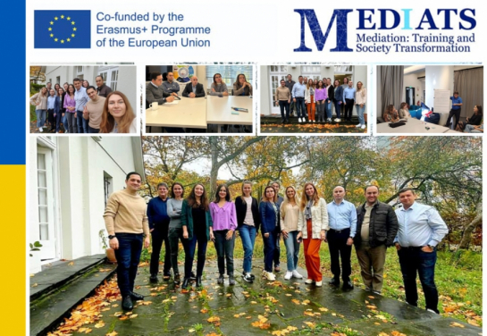

International Mediation Summer School by KROK BSK

On July 11-15, 2022, as part of MEDIATS project «Mediation: Training and Society Transformation / MEDIATS», an online International Summer Mediation School was held by the KROK BSK.
5 days of modern concentrated knowledge on mediation and conflict resolution were provided by Krok BSK!
Conflict management skills are relevant in any field where people interact with people. Students were teaching, delivering products or services, helped solve problems. They found out how to manage organizations, processes and people, agree. The International Summer Mediation School - 2022 was dedicated to mastering the practical basics of mediation and conflict management. Participation in the International Summer Mediation School provided information on the practical application of mediation and other conflict resolution methods.
Participation in the events was useful for both experienced professionals and those who are just being acquainted with mediation.
The event took place online (Zoom).
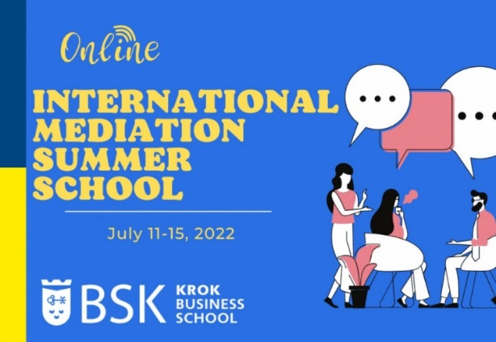
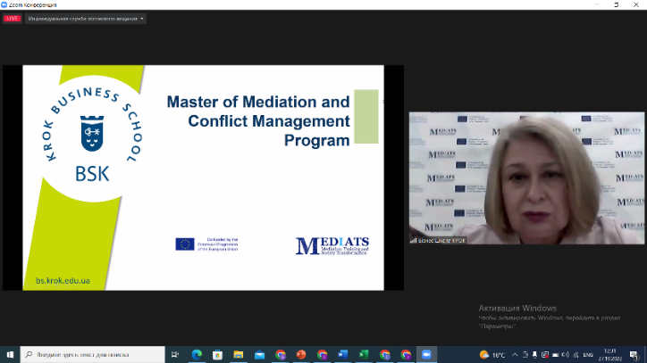

30-31 October 2022 Project Steering Committee 6 in Batumi State University, Georgia
30-31 October 2022 in frameworks of the EU Erasmus+ CBHE project "Mediation: Training and Society Transformation/ MEDIATS", 6th Project Steering Committee was hosted by Batumi State University, Georgia.
The event included discussion of management, documentation and reporting aspects. As the project is on the final stage of implementation, the project overview was done and achieved results comparing to indicators were considered.
Experienced team of Ilia State University - Manana Salukvadze, International Projects Financial Coordinator, and Salome Shedania, Deputy Head of Research Development, organized management sessions on preparation of the final report, considering each part of the report in details – e-form, annexes, financial statement, supporting documentation. They provided valuable recommendations and consultations to MEDIATS partners.
BSU organized University Tour for the participants and presented Mediation Centre.
We are sincerely grateful to Batumi State University for hosting of the event, to Ilia State University for - providing qualified recommendations and to all partners for active participation and pleasant atmosphere!
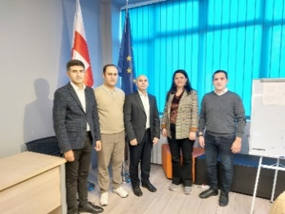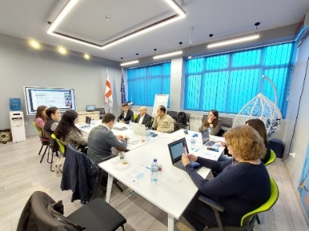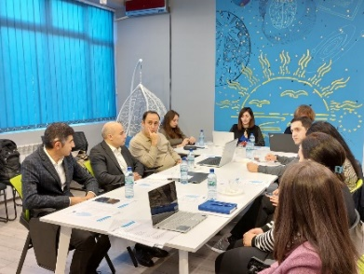
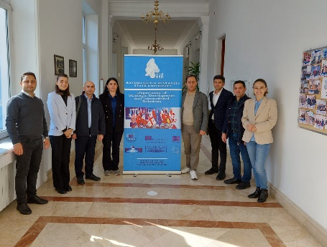

Mediators’ Certification Program

ISU School of law has created certification program for mediators, in compliance with the standards established by the Association of Mediators of Georgia. The purpose of the certification program is to provide training for those who want to become a mediator in Georgia.
The working group developed structure of the program and prepared it for accreditation.
After completing some formalities, the program will be submitted to the Georgian Mediators Association to get institutional accreditation.

International Highlight Event 2 in Tbilisi, Georgia

On October 26-28, Ilia State University School of Law, in cooperation with MEDIATS project partner and the Association of Mediators of Georgia, held the International Highlight Event in Tbilisi, Georgia.
The event was opened with a welcome speech by Irakli Porchkhidze, the Dean of the Law School of Ilia State University, Jan Van Zwieten, the Rector of the Netherlands Business Academy, and Irakli Kandashvili, the Chairman of the Association of Mediators of Georgia.
At the panel discussion, leading specialists in the field and representatives of the academic field discussed about the development trends of mediation in Georgia and in partner countries and emphasized the role of courts and educational institutions in this process.
At the event, a Memorandum of Understanding was signed between the Association of Mediators of Georgia and the Business Academy of the Netherlands.
In the final part of the first day event, a workshop organized by the Netherlands Business Academy and Ilia State University was held for mediators and for other interested parties.
Also, within the framework of the event, the Georgian mediator conducted a workshop for those interested in Mediation, as well as the presentation of publication #2 and presentations of partners about the implementation of the project were held to the general public.

News from CHNU

Events of CHNU Project Team of MEDIATS Project
(April-November, 2022)

New facets of demand for the professions of lawyer and mediator in modern realities

April, 2022 – an interesting and useful event was held at the Educational and Scientific Laboratory of Mediation, Negotiations and Arbitration of the Department of Public Law of the Yuriy Fedkovych Chernivtsi National University within the framework of the MEDIATS Project “Mediation: Training and Society Transformation” of the ERASMUS+ KA2: CHBE Program training “Emotional competence of a lawyer and mediator as a point of support in difficult conditions”.
The key focus was on the most important aspects of emotional competence in the work of a lawyer, on the most painful problems of lack of soft skills in both experienced and future lawyers, which arise in legal practice, especially in wartime.
Link: https://law.chnu.edu.ua/novi-hrani-zatrebuvanosti-profesii-pravnyka-ta-mediatora-u-suchasnykh-realiiakh/
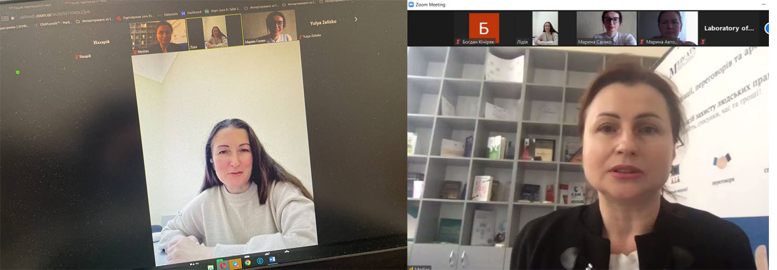

Mediation for internally displaced persons under martial law
May, 2022 – Illia Yuriychuk, member of the ERASMUS+ KA2: CHBE Program and the manager of the project group from CHNU prepared a blog post about mediation.
Mediation can be safely called a tool for establishing a national dialogue, because, in connection with the state of war in our country, many people were forced to leave their homes and take refuge in the West of Ukraine (in particular, in Chernivtsi). Each person and family has its own needs, its own rules, and its own habits, which may not always be liked by other people, which can cause conflict.
In order to successfully resolve the conflict, one of the most modern and effective methods of dispute resolution can come to the rescue - mediation.
Link: https://law.chnu.edu.ua/mediatsiia-dlia-vpo-v-umovakh-voiennoho-stanu/

Mediation networking
May, 2022 – Community of mediators of Ukraine organized a wonderful event for networking and community support, where the Laboratory of Mediation, Negotiations, and Arbitration of the Department of Public Law of the Yuriy Fedkovych Chernivtsi National University, the MEDIATS Project “Mediation: Training and Society Transformation” of the ERASMUS+ KA2: CHBE Program and the unique master's program MEDIATION, specialty 081 Law, which is implemented by the Yuriy Fedkovych Chernivtsi National University. The speakers revealed the peculiarities of the establishment and development of their centers, what they “live” today, which areas of activity and practices in mediation are currently most in demand, who are the partners in the mediation market today, what new challenges mediators faced after the start of the active phase of the war and how they were responded to, how you can join the activities of the centers, what support you can get or become, create joint activities/projects, etc.
Link: https://www.facebook.com/story.php?story_fbid=1012061052810184&id=134400660576232
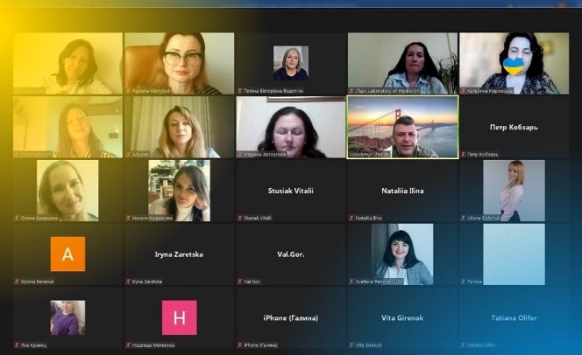

New horizons of cooperation in the field of mediation
July, 2022 – Two groups of the certificate program “Professional mediator: basic training” received certificates. A feature of this certificate program is the fruitful synergy of the Educational and Scientific Laboratory of Mediation, Negotiations, and Arbitration of the Department of Public Law of the Faculty of Law of the Yuriy Fedkovych Chernivtsi National University, the Notary Chamber of Ukraine, the NGO “Bukovyna Mediation Center”, and the bright constellation of the mediation community of Kyiv, Odesa, Lviv, Chernivtsi.
The certificate program is organized with the assistance of the MEDIATS Project “Mediation: Training and Society Transformation” of the ERASMUS+ KA2: CHBE Program and the manager of the project group from CHNU Ruslana Havrylyuk.
Link: https://law.chnu.edu.ua/novi-horyzonty-spivpratsi-u-sferi-mediatsii/
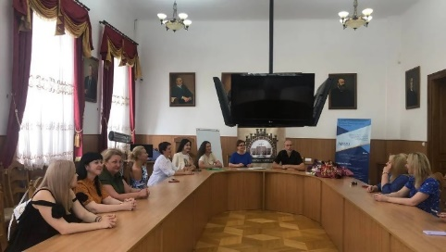

Five steps along the route of restorative justice in the Bergamo style
July 4-8, 2022 – Ruslana Havrylyuk, the manager of the the MEDIATS Project “Mediation: Training and Society Transformation” of the ERASMUS+ KA2: CHBE Program took part in the summer school “Fundamentals and routes of restorative justice” was held on the basis of the Restorative Justice Center of the University of Bergamo (Bergamo, Italy). Kartabia reform and restorative justice. Possibilities and Limits”, which once again demonstrated for all its participants, that during the time of Russian aggression, the full-scale war of Russia against Ukraine, Ukrainian society more than ever needs to analyze the progress of civilization and search for its own valuable identity, including understanding and settlement of conflicts (disputes).
Link: https://law.chnu.edu.ua/vidnovne-pravosuddia-po-berhamsky/
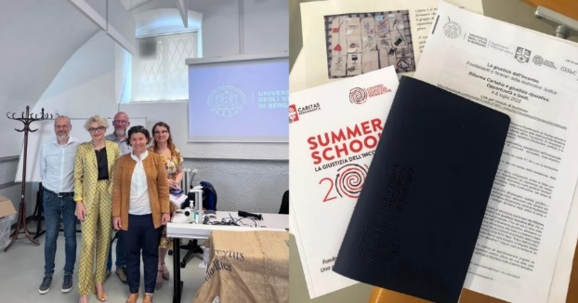

Meeting with representatives of the Chernivtsi local center for providing free secondary legal assistance
July, 2022 – meeting-discussion was held with the Educational and Scientific Laboratory of Mediation, Negotiations, and Arbitration of the Department of Public Law of the Faculty of Law of the Yuriy Fedkovych Chernivtsi National University cooperation with the NGO “Bukovyna Mediation Center”, representatives of the MEDIATS Project “Mediation: Training and Society Transformation” of the ERASMUS+ KA2: CHBE Program and representatives of the Chernivtsi local center on the provision of free secondary legal assistance. During the meeting, issues related to free legal assistance, prospects, and directions for further cooperation regarding the implementation and implementation of the application of mediation in practice during the resolution of cases were discussed.
Link: https://facebook.com/story.php?story_fbid=1031058154243807&id=134400660576232
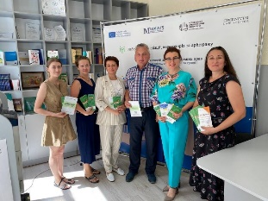

A brisk start of the mediation laboratory's cooperation with society institutions
September, 2022 – In particular, as part of the Educational and Scientific Laboratory of Mediation, Negotiations, and Arbitration of the Department of Public Law of the Faculty of Law of the Yuriy Fedkovych Chernivtsi National University cooperation with the NGO “Bukovyna Mediation Center” with the assistance of the MEDIATS Project “Mediation: Training and Society Transformation” of the ERASMUS+ KA2: CHBE Program and mobile groups consisting of specialists in support of interaction and conflict management in places of assistance to internally displaced persons, this game-meeting and a meeting on the practice of restoring vital resources took place. The work of these mobile groups consists of preventing conflicts by improving conflict sensitivity and, as a result, increasing the effectiveness of communication and responding to conflicts.
Link: https://law.chnu.edu.ua/start-spivpratsi-laboratorii-mediatsii-z-instytutamy-hromadianskoho-suspilstva/
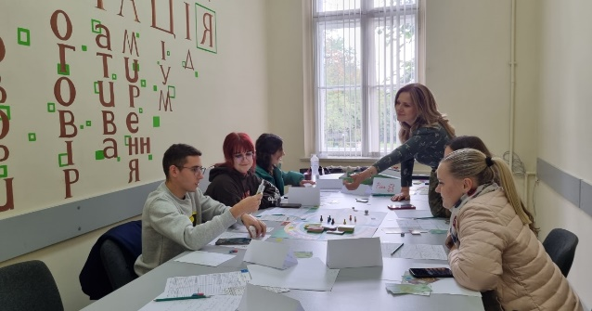

Interdisciplinary knowledge of humanistic mediation
October, 2022 – Ruslana Havrylyuk, the manager of the the MEDIATS Project “Mediation: Training and Society Transformation” of the ERASMUS+ KA2: CHBE Program and the Educational and Scientific Laboratory of Mediation, Negotiations, and Arbitration of the Department of Public Law of the Faculty of Law of the Yuriy Fedkovych Chernivtsi National University organized the presentation of the book by author Jacqueline Morino “Humanistic Mediation. Another look into the future” in Ukrainian. The event was attended by students and teachers of the Department of Public Law, as well as the Department of Psychology, which created a unique kaleidoscope of opinions when discussing the features of humanistic mediation. Masters of EPP Mediation took an active part in this event.
Link: https://law.chnu.edu.ua/mizhdystsyplinarne-piznannia-humanistychnoi-mediatsii/
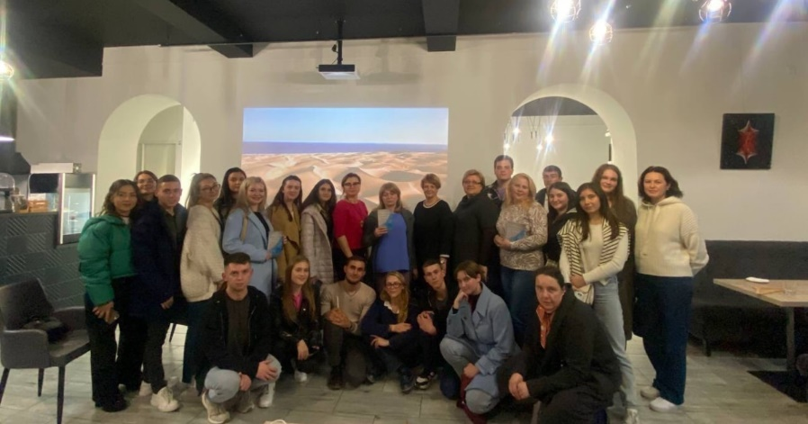

The role of a lawyer in embodying the values of humanistic mediation
October, 2022 – Ruslana Havrylyuk, the manager of the MEDIATS Project “Mediation: Training and Society Transformation” of the ERASMUS+ KA2: CHBE Program and the Educational and Scientific Laboratory of Mediation, Negotiations, and Arbitration of the Department of Public Law of the Faculty of Law of the Yuriy Fedkovych Chernivtsi National University organized the presentation of Jacqueline Moreno's book “Humanistic Mediation. Another look into the future”.
Link: https://law.chnu.edu.ua/rol-pravnyka-u-vtilenni-tsinnostei-humanistychnoi-mediatsii/
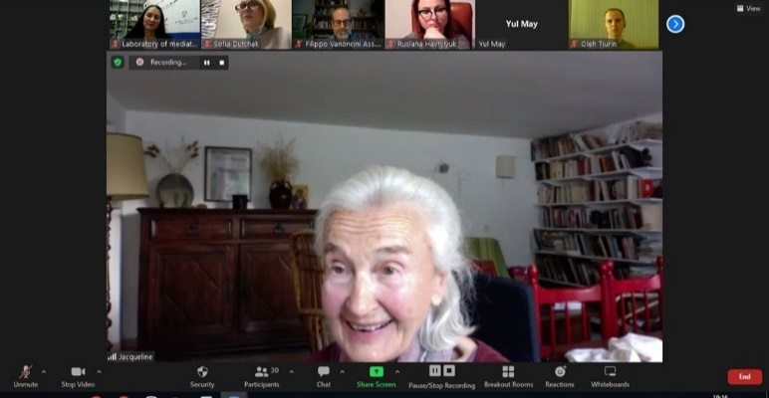

The admission of students for the Master's program in Mediation in 2022
19 full-time students and 12 part-time students enrolled at the Educational and Professional Program “Mediation”.Students share their impressions about studying at EPP “Mediation”.
Link: https://www.facebook.com/story.php?story_fbid=621493756436518&id=100057276976606

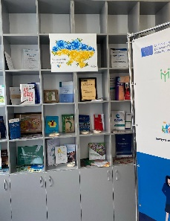

Prepared by
Project Team of MEDIATS Project from CHNU

News from Khazar University

Khazar University Faculty Member Appointed a Member of Mediation Council's Qualification Commission

Huseyn Aliyev, the mediator-trainer teaching "Mediation: Theory and Practice" at Khazar University's School of Economics and Management, has been appointed a member of the Mediation Council's Qualification Commission. The decision was made at a joint meeting of the Qualification and Disciplinary Commissions of the Mediation Council.
H. Aliyev graduated with a bachelor's degree in International Law from Baku State University in 2003-2007, and a master's degree in Business Administration (MBA) from Girne American University of the Turkish Republic of Northern Cyprus in 2007-2009. From 2011 to 2012, he studied at the University of Tulane under the US Department of State's Edmund S. Muskie Exchange Program (Muskie), earning a master's degree in International and Comparative Law. H. Aliyev, who specialized in corporate and commercial law and has 12 years of professional experience, currently works as the head of the legal department at an oil and gas company. Prior to his appointment as a member of the Qualification Commission, he was a member of the Mediation Council's Project Management Working Group. He is also a new member of the Bar Association of the Republic of Azerbaijan. H. Aliyev has been teaching "Out-of-Court Dispute Resolution" at Baku State University since 2012 and "Mediation: Theory and Practice" at Khazar University since 2022.
On March 29, 2022, Huquq.az and other websites published news about it.
https://khazar.org/en/news/5855
https://www.e-huquq.az/az/news/mediation/46067.html

Coordinator of Psychology Department at "Labor Mediation" training

Malak Karimova, coordinator of Khazar University Psychology Department, participated in the "Labor Mediation" training organized by the Academy of Justice on July 15-19, 2022 and successfully passed the exam.
The training theoretically taught the use of mediation in labor disputes and demonstrated it through practical exercises.
Note that Melek Karimova was appointed a member of the Mediation Council of the Republic of Azerbaijan.
It is expected that the Mediation MBA program established under the Erasmus+ MEDIATS project at Khazar University will make a great contribution to the newly introduced mediation process in Azerbaijan.
https://khazar.org/en/news/6099

Coordinator of Psychology Department in Public Discussion on Mediation

Melek Karimova, Coordinator of Khazar University Psychology Department, participated in an educational public discussion on "The role of state bodies and employers in the successful resolution of disputes during mediation processes" organized by the Commissioner for Human Rights of the Republic of Azerbaijan, the Ministry of Justice and the Mediation Council on July 26, 2022.
At the event, after the Deputy Minister of Labor and Social Protection of the Population of the Republic of Azerbaijan Anar Aliyev, the representative of the United Nations High Commissioner for Refugees in Azerbaijan Guido Ambroso, the Commissioner for Human Rights (Ombudsman) of the Republic of Azerbaijan Sabina Aliyeva, the head of the Department of Human Rights and Public Relations of the Ministry of Justice Aynur Sabitova and Nadir Adilov, Chairman of the Board of Mediation Council delivered their speeches, public discussion was held regarding current problems and future prospects.
https://khazar.org/en/news/6100

Interview with Khazar University mediation MBA student in "Adalat" newspaper

In the August 26, 2022, issue and website of "Adalat" newspaper, an extensive interview with Gasim Shaliyev, a member of the Mediation Council and director of Baku Mediation Organization No. 15, MBA student in mediation of Khazar University, was published.
In the interview, Gasim Shaliyev gave detailed information about the term and concept of “mediation”, the steps taken regarding its development in Azerbaijan, the cases that will be involved in the mediation process according to the current legislation, and optimistically stated that "There will be no unresolved disputes!"
The interview was conducted by Bunyamin Bunyadzadeh.
https://khazar.org/en/news/6128

Effective cooperation established between Khazar University and the Mediation Organization

On October 18, 2022, a meeting was held with the administration of Mediation Organization Baku No.15 at Khazar University.
Rector of Khazar University Irade Khalilova, Dean of the School of Economics and Management Jeyhun Mammadov, Member of the Mediation Council, Director of Mediation Organization Baku No. 15 Gasim Shaliyev and National Mediation Trainer Natig Mammadov took part in the meeting.
A memorandum was signed between Khazar University and Baku Mediation Organization No. 15 at the meeting where the establishment of mutual cooperation was discussed in detail.
According to the memorandum, in scientific and scientific-practical conferences, seminars and forums held to create mediation traditions in the business environment, to apply the world's leading mediation achievements to the development of local entrepreneurship, to educate entrepreneurship subjects in this field and to assist in the development of their activities, the scientific staff of the University and the specialists of the Mediation Organization will work together in the study of the relevant experience and the formation of scientific basis.
Within the framework of that memorandum, the Mediation Organization will create conditions for the University's students majoring in mediation, economics, finance, business and management to connect

the research, course and graduation works, and the dissertation topics of the master's students with the content of the projects implemented by the Organization.
According to the agreement, university students will learn negotiation and mediation in business conflicts at the Mediation Organization, and participate in daily seminars and practical programs, in order to train competitive local personnel in mediation, economics, business and management specialties based on partnership with world-renowned universities. A number of websites published news about the event.
https://khazar.org/en/news/6247
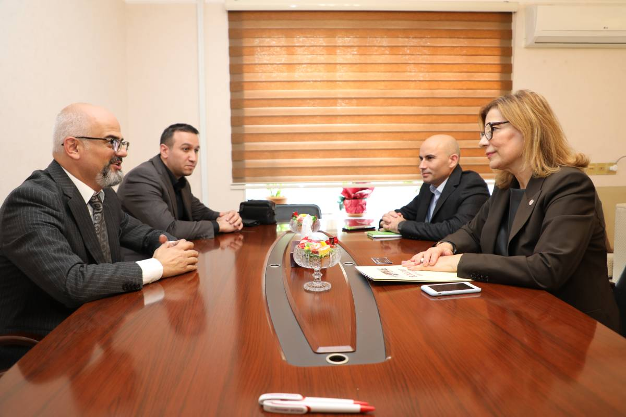

Dean of School of Economics and Management in MEDIATS Project Meeting at Freie Universität Berlin in Germany

On October 20-23, 2022, within the framework of the project “Mediation: Training and Society Transformation” MEDIATS coordinated by the Netherlands Business Academy in the Netherlands and co-coordinated by KROK University in Ukraine, Dr. Jeyhun Mammadov, Dean of the School of Economics and Management, visited Freie Universität Berlin in Germany.

The visit started on October 21 with a workshop on Impact and Sustainability in Business Idea Development. MEDIATS partners formed a working group and worked on the sustainability of mediation structures and the program. As a result of the workshop, the MEDIATS team developed a new project to be presented at the Entrepreneurship Summit on October 22.
On October 22, a management meeting was held, and the implementation progress of MEDIATS project activities was discussed, and future activities were defined.
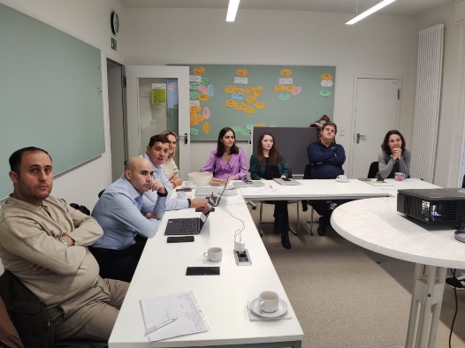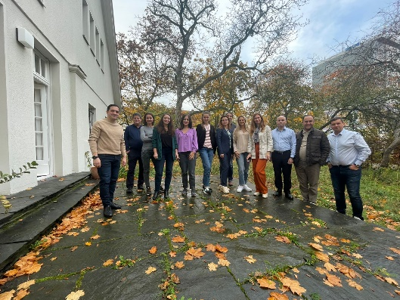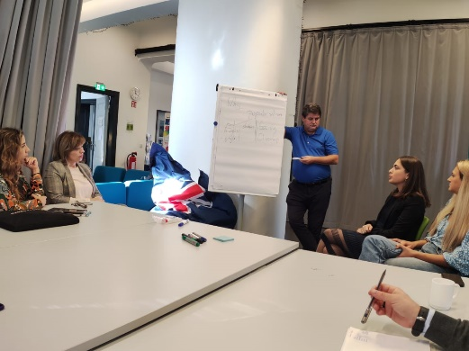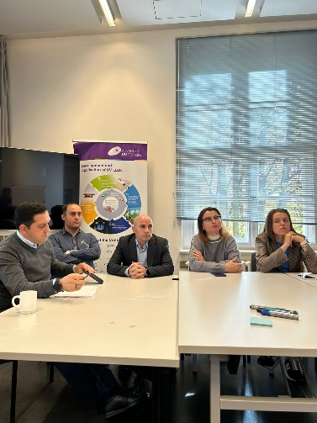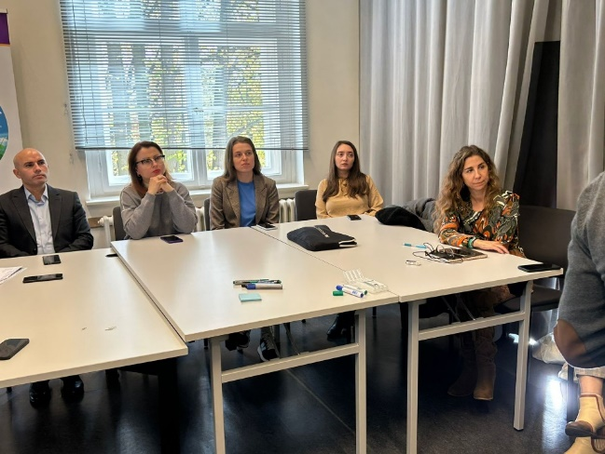

Khazar University Staff Members Took Part in MEDIATS Project Meetings

On October 29 – November 02, 2022, within the framework of the project “Mediation: Training and Society Transformation” MEDIATS coordinated by the Netherlands Business Academy in the Netherlands and co-coordinated by KROK University in Ukraine, International Highlight Event and Management Meeting took place at Ilia State University and Batumi Shota Rustaveli State University in Georgia, respectively.
At the International Highlight Event on October 25-29, Khazar University was represented by Dr. Jeyhun Mammadov, Dean of the School of Economics and Management, Ms. Malak Karimova, A Certified Mediator and Coordinator at the Psychology Department, and Ms. Alida Mahmudova, A Certified Mediator and Instructor of Mediation at Graduate School of Economics and Business.
Followed by the presentation of Ms. Alida Mahmudova on the development of mediation in Azerbaijan, Khazar University staff participated in the panel discussion of comparative trends in Azerbaijan, Georgia, Ukraine, and the European Union. Ms. Alida Mahmudova and Ms. Malak Karimova shared their professional experiences and answered audience questions.
Meanwhile, Dr. Jeyhun Mammadov delivered a speech on the project implementation at Khazar University. He gave detailed information to the participants about the structure of the MBA program in Mediation, the number of students admitted, the syllabuses, and credit requirements. Touching on the issue of project sustainability, Dr. Mammadov emphasized ongoing work on the extension of cooperation with partner universities and the Mediation Council of Azerbaijan, and the organization of continuous joint events and seminars related to mediation with Ganja State University.
At the Management Meeting on October 29 – November 02, Khazar University was represented by Dr. Jeyhun Mammadov and Ms. Malak Karimova. Preparation of the Final Report E-Form, Final Financial Statements, and Annexes was overviewed and discussed.

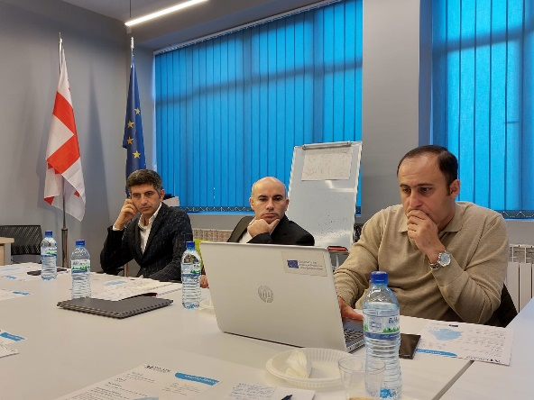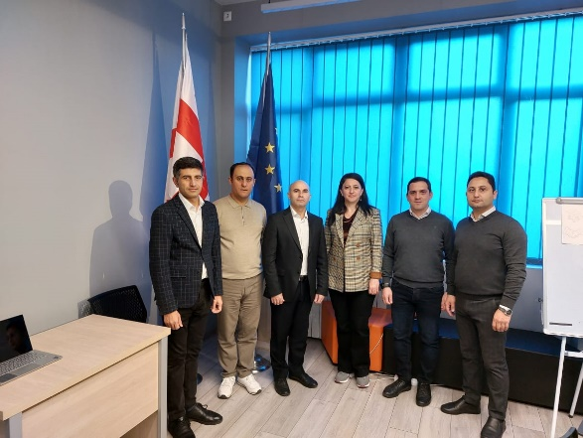

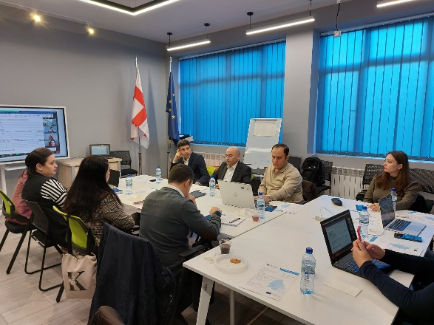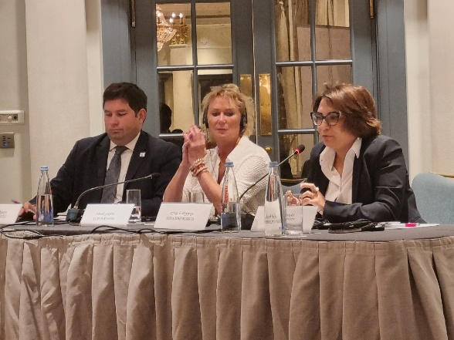

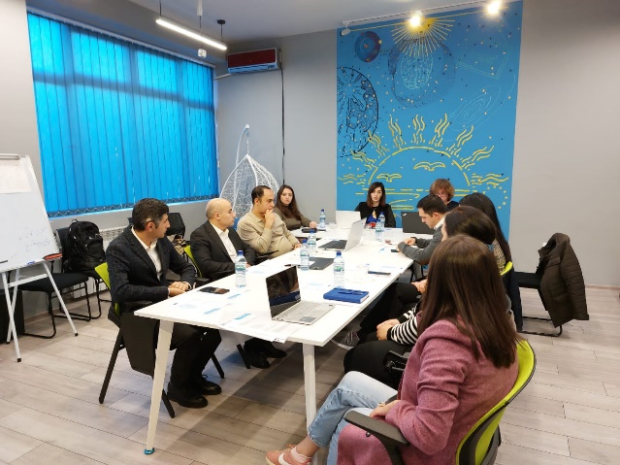

News from KKNU
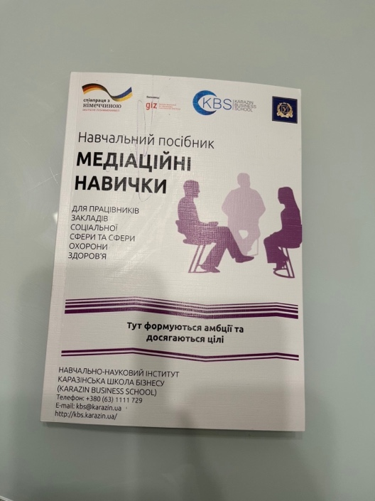
The MEDIATS project became one of the drivers of the development of the Karazin Business School several years ago, and now mediation does not leave the thoughts and initiatives of our team.
Karazin University continues to work actively in the field of mediation and already has new achievements. During 2022, despite the war and other obstacles, a spin-off of the project will be implemented - the certification program "Mediation skills in the social sphere and the sphere of health care", within the framework of which more than 20 social and healthcare workers from different regions of Ukraine got acquainted with mediation and features of its application in modern conditions. Based on the results of this spin-off project, a manual on the development of mediation skills was developed for representatives of the social and healthcare spheres.

Finalization of MEDIATS project

The time has come - we have to finalise the MEDIATS project, but it does not mean the end of active work and cooperation in the field of mediation for its participants. The Karazin Business School’s team plans to implement a set of activities to ensure the sustainability of project results, including:
- meetings with graduates of the program and future students;
- scientific publications;
- participation in public events in Ukraine and abroad (online and offline);
- development of new spin-offs based on the project results, etc.
The MEDIATS project gave a good start to the implementation and dissemination of mediation values ​​in Ukraine, therefore our task in the future is to maintain the sustainability of its results and develop new initiatives in the field of mediation.

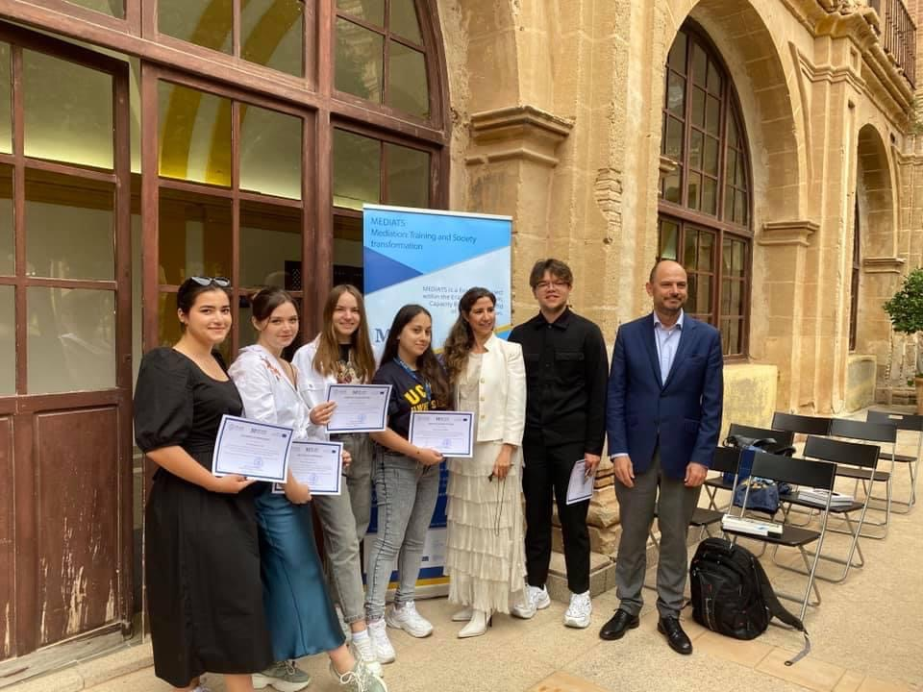
Soon (in November 2022), the educational journey of the second cohort of students under the "Management: Mediation" program is coming to the end. Karazin mediators worked actively during the entire training period: they completed two-week internships at the Catholic University of San Antonio (Murcia, Spain) and at the Netherlands Business Academy (Dordrecht, Netherlands), solved hundreds of cases and learned the secrets of mediation from European experts. Now the participants of the program are preparing to defend their qualification works and further conquer the world of mediation and conflict resolution.

News from Turība University
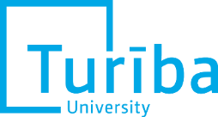

THE MEDIATS PROJECT – STRONG CROSS-UNIVERSITY INITIATIVE
The MEDIATS project created an opportunity for lecturers from the project partner countries not only to increase their knowledge about mediation, but also to gain significant international experience and create a mutually supportive academic network in the field of mediation. The project partners also cooperated mutually in other parallel projects. For example, as part of the CODEMAL project implemented by the Turība University (Latvia), in November 2021, mediators and lawyers from Lithuania, Latvia, Italy and Austria participated in the exchange visit to the Netherlands Business Academy, where, inter alia, they participated in working groups, seminars and discussions with the participants of the MEDIATS project – teachers and students. Such a unique experience confirmed the ability of mediation as a dispute resolution technique to function without border restrictions. The contacts gained during the visit are also currently being used to develop mediation at the cross-border level.

Likewise, the academic contacts obtained within the MEDIATS project created an opportunity to cooperate in the creation of academic literature. For example, the collective monograph "Interdisciplinary skills for cooperation and conflict management" was written as part of the Erasmus + project DISCOM implemented by the Turība University (Latvia), where professor and mediator Ruslana Havrylyuk – a certified mediator and the Head of Department of Public Law, Yuriy Fedkovych Chernivtsi National University, which is the MEDIATS project partner, kindly agreed to be the scientific reviewer.
On November 5, 2022 the associate professor of Turiba University presented a speech “A toolbox of a successful mediator” in the conference – national dissemination event organized by the Ganja State University (Azerbaijan).
More information on mediation topic in Turiba University and mediation projects: http://mediation.turiba.lv
Photos: Study visit to the Netherlands, November 2021

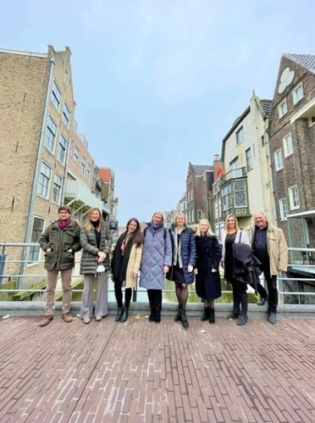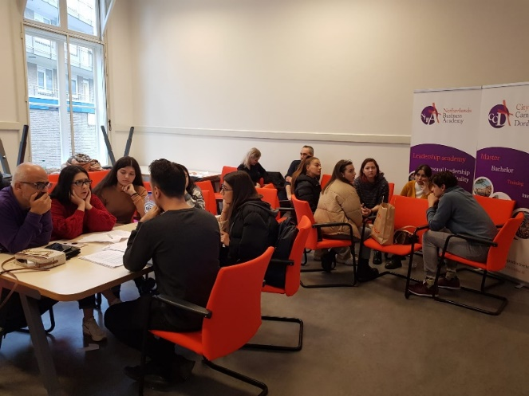

THE MEDIATION CENTER OF GSU INVITED STUDENTS TO ATTEND SUMMER SCHOOL FOR MEDIATION

On July 4-8, 2022 West Ukrainian National University, together with Batumi Shota Rustaveli State University and Netherlands Business Academy had been organized the Online International Summer School “New Way”: Negotiation and Mediation. The program summer school mainly had been focused on lectures, seminars, an interactive format “live library”, workshops, training simulations, problem-situation analysis, and case analysis of practical experience experts from Ukraine, Georgia, Netherlands, Spain, Latvia, USA. The interactive tools and new approaches in the field of mediation and the art of negotiation, the potential entrants to the Master’s Program of the NNIK ZUNU “Psychology of Negotiations and Mediation” are some of the interesting topics that attracted our students. Ganja State University team which was coordinated by Ruslan Mammadov, Head of the Mediation Center was actively enrolled in the online discussions.

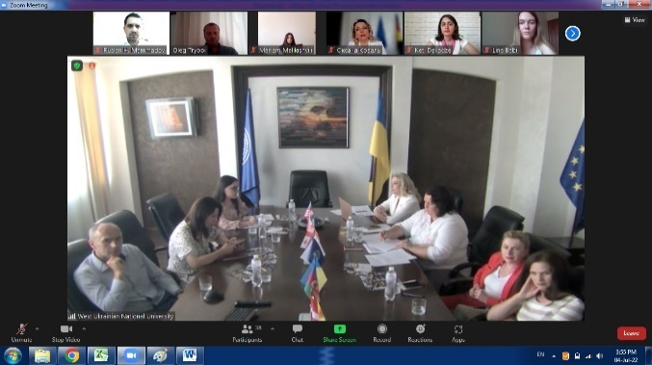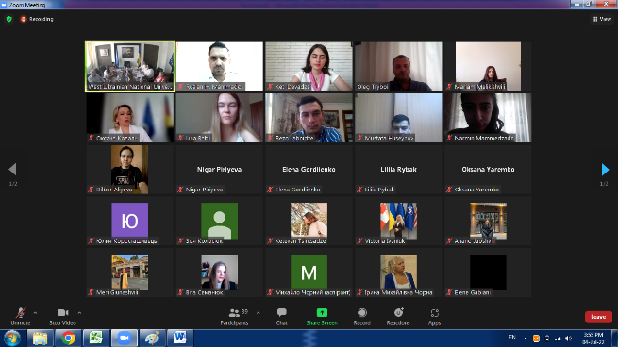

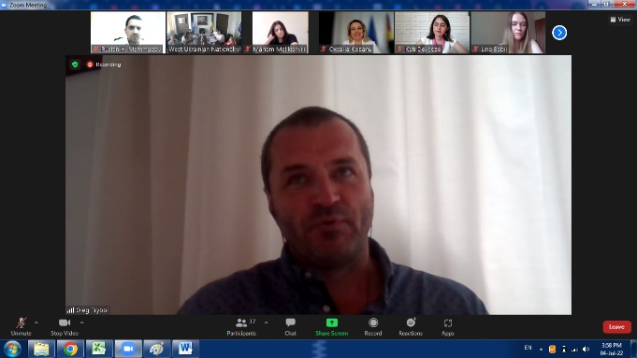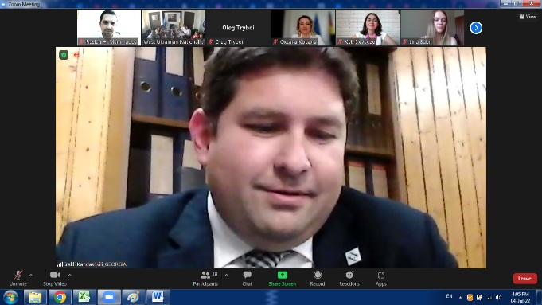

VASIF HASANOV, THE MANAGER OF THE MEDIATS PROJECT MADE A SPEECH AT THE ACADEMIC COUNCIL OF THE UNIVERSITY

On October 04, 2021, the manager of GSU MEDIATS Project Vasif Hasanov made a speech during the Academic Council meeting about the final phase and implementation of the MEDIATS Project and activities that expecting to finalize by the end of the project. During the meeting, according to the work packages of the Project he had reported about the ending of audit control of EACEA which the University successfully finished it. Vasif Hasanov, the Director of the Department of Innovations of the University, also gave detailed information about the activities of the “Mediation Center” at the university within the Erasmus + KA2 MEDIATS project. On the other hand, the local coordinator of the project Vasif Hasanov gave detailed information about the goals and objectives, activities, structure, and application rules of the “Mediation Center” established by the relevant order of the rector and upcoming events and dissemination actions that expecting to organize it during 1 month. He talked about the last trips to Germany and Georgia for Tbilisi and Batumi meetings, also he gave some details information about the national dissemination event which is planned to be held in Ganja according to work package of the Project.
The meeting ended with answering some questions of staff members of Academic Council.
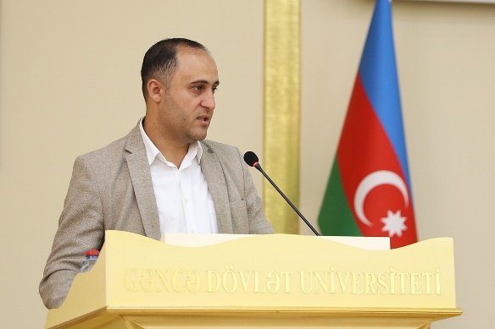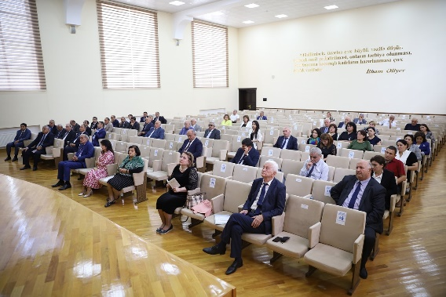

GSU staff attended to Sustainability training and a management meeting in a framework of MEDIATS Project.

In frameworks of the EU Erasmus+ Capacity Building of Higher Education project „Mediation: Training and Society Transformation/ MEDIATS" Sustainability Training and Project Management Meeting had been held on 20-23 October 2022 in Berlin, Germany.
According to the on-going work package of MEDIATS project, 2 staff members of our University Vasif Hasanov, the Director of Department of Innovations and Ruslan Mammadov, Head of International Relations Office had been attended to international event. During 2 days short term event, the project partners from Germany, Spain, Netherlands, Ukraine, Georgia and Azerbaijan were discussed the sustainability and dissemination actions of the MEDIATS project. Lately, Consortium members elaborated and presented on-going work package of the Project. Projects results and activities that made by GSU Project Team had been accepted by the partners and coordinators of the Project.
Before finalising the MEDIATS project still some activities are plan to be organize by GSU Team members.

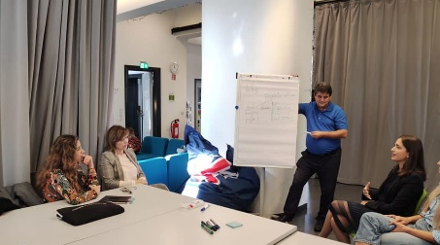
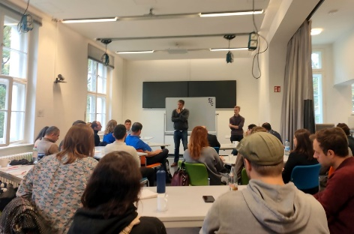
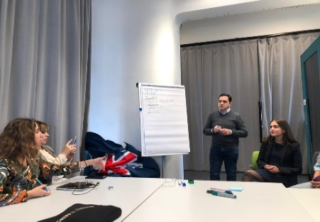

GSU STAFF ATTENDED TO THE WORKSHOP ON HOW TO PREPARE FINAL REPORTS FOR EU FUNDED MEDIATS PROJECT

GSU staff attended to the International Highlight Event due EU funded MEDIATS Project.
26-28 October, 2022 due to the EU funded Erasmus plus MEDIATS Project International Highlight Event on dissemination and promotion of mediation values had been organized in Tbilisi, the Republic of Georgia.
According to the on-going work package of EU funded Eramus plus MEDIATS project, 4 staff members of our University Vasif Hasanov, the Director of Department of Innovations and Ruslan Mammadov, Head of International Relations Office, Asif Hasanov, Head of ICT Office and Razim Aliyev, Head of Innovation Transfer Technology Office had been attended to international dissemination event. The hybrid meeting which is hosted by Ilia State University mainly dedicated to the promotion and disseminating mediation values and its transformation to the society. Regarding the program activities the project partners from, Spain, Netherlands, Ukraine, Georgia and Azerbaijan were attended both presently and virtually to the international highlight event.
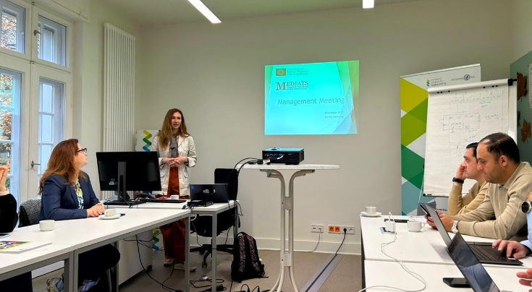
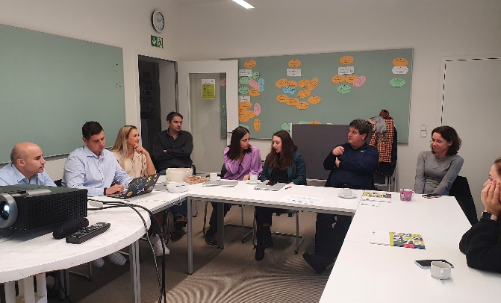
The Mediation Association of Georgia and personally the chairman of the Association Mr. Irakli Kandashvili had been attended to the event as a panel speaker and he made a presentation on development of mediation Georgia and comparative trends in Ukraine, Azerbaijan, and EU. Lately, trainers from NLBA Gea van Klompenburg and Marjon Kuipers were organised workshop for lawyers, mediators and attended from different local and international organisations. In 3 days event participants from Ganja State and Khazar university were represented Azerbaijan.

.

GANJA STATE UNIVERSITY ORGANIZED THE INTERNATIONAL HIGHLIGHT EVENT DUE TO EU FUNDED MEDIATS PROJECT

05-06 of November 2022 GSU Project team members organized the International Highlight Event in Ganja due to EU funded MEDIATS Project where the dissemination and promotion of mediation values and its transformation to the Society performed to the broader audience due to a hybrid seminar. Regarding the program activities the project partners Prof. Jan Van Zwieten from Netherlands Business Academy (Netherlands), Prof. Dana Rone from Turiba University (Latvia), and Prof. Maria Mendez Rocasolano from UCAM Murcia (Spain) supported the dissemination event with their valuable practices with virtual presentations on the different aspects of mediation and its promotion. On behalf of the Azerbaijan Mediation Council, Ms. Sima Yagubova deputy of the Chairman of the Mediation Council also made a presentation on mediation transformation and its role in the national society and also Jeyhun Mammadov (Khazar University) and Malak Karimova (Khazar University) made a project based presentation to the audience. Besides, local mediation organizations such as Mediation Center N1 and Mediation Center N15, independent lawyers and mediators, and also staff and students of Ganja State University joined the seminar with both online and face-to-face formats.
After finalizing the presentations, the introduction of the GSU Mediation Center to the guest had been made by Ruslan Mammadov, head of the Mediation Center of GSU. Afterward, on 06 November 2022, GSU Project team members and some of the event’s participants visited the main campus of Ganja State University. Following, a visit to the Bureau of Lawyers N1 and to the Mediation Center N1 of Ganja city had been organized. During the meeting with the Mediation Center N1 of Ganja city initial agreement on further cooperation had been agreed.

News from ISU School of Law

In August 2022, the second collection of articles on mediation in Georgian was published by the ISU School of Law. The publication is related to the development trends of mediation on the example of the experience of teaching mediation in Georgia.
The Publication was created with the support of the MEDIATS project and it includes articles by professors and students of ISU School of Law and BSU.
The Publication is intended for anyone interested in learning/teaching of mediation and is available both physically in Library as well as electronically in the following link:
https://bit.ly/3RhtOpp

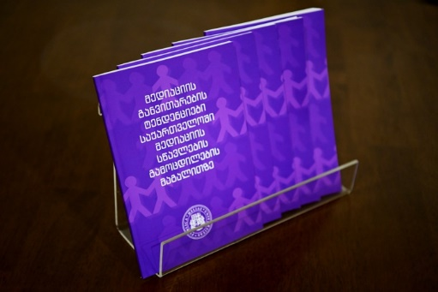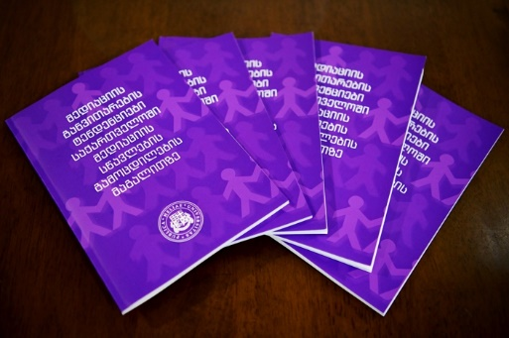

The first Alumni of Mediation Module

On September 15, ISU School of Law awarded the first graduates of the renewed Private (Business) Law Master's Program (Mediation Module) with certificates.
The updated master's program Mediation Module was developed with the support of the MEDIATS project and received the first cohort of students in 2020.

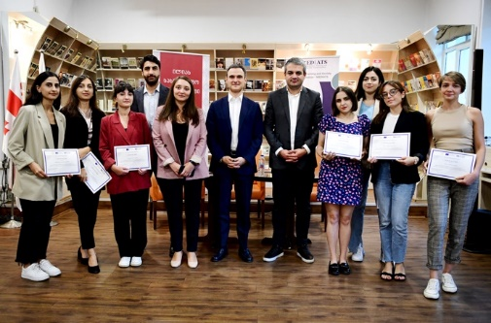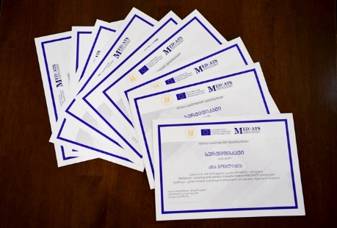

Participation in sustainability training in Berlin

In October 21-23, ISU team participated in a sustainability workshop held in Berlin, where together with the project partners, they discussed the plan to maintain the sustainability of MEDIATS results after the end of the project.
The workshop was organized by MEDIATS project partner from German, Hultgren Nachhaltigkeitsberatung UG.

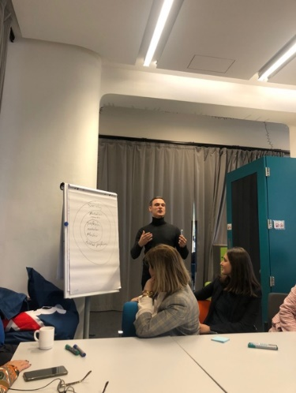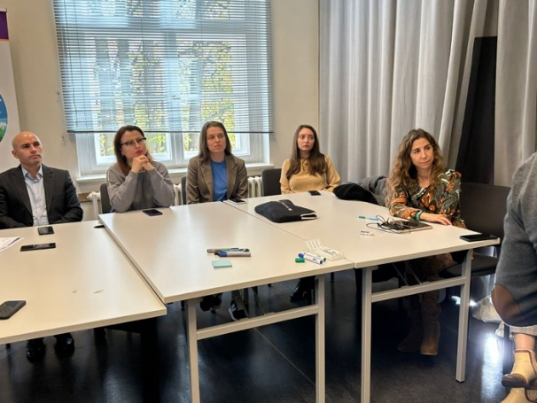
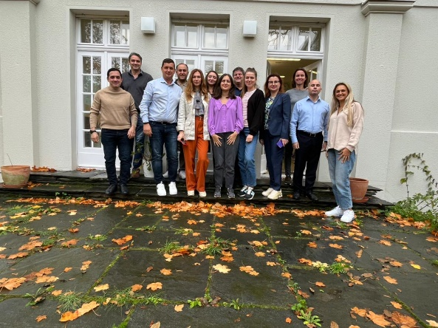

Promotional video

ISU team has created promo video, where there are some interviews with several people about the Mediation Institute in general, the MEDIATS project as well as the role of Ilia State University in facilitating mediation processes.
Link of the video: https://fb.watch/gzcaLAqjAs/?mibextid=BD8QQn

Mediators’ Certification Program

ISU School of law has created certification program for mediators, in compliance with the standards established by the Association of Mediators of Georgia. The purpose of the certification program is to provide training for those who want to become a mediator in Georgia.
The working group developed structure of the program and prepared it for accreditation.
After completing some formalities, the program will be submitted to the Georgian Mediators Association to get institutional accreditation.

